Analysis Report

South Metropolitan TAFE | RAD

Carl Haricombe

Sprint 1

2020

Table of Contents

Business Rules in Software Development 1

Managed Services Quality Assurance 2

Quality Assurance: 2

Software Verification: 2

Software Validity: 2

Client Requirements 3

Project Plan 4

Notes: 5

Meeting 5

Analysis Documentation 5

Multi-platform 6

Backend Code 6

Test Documentation 7

Master Documentation 7

Presentation 8

Source Control System 9

First edition 9

Final edition 9

Multiplatform Report 10

# Business Rules in Software Development

The business rule in software development refers to separating the coding end of the application into a logical stream where each person in the team is then assigned to an area in that stream. This will often come into effect when the client has a change of mind in what they want the application to do or look like.

Being given the RAD Agile methodology we had to follow the 6 steps to designing and developing the final prototype and having run through the Quality Assurance we decided as a team it would be best to undergo a grey box testing validation where Calvin Moylan handled the backend code to develop what the client required. Then Panashe Madakasi had to do the testing of the front to ensure that Calvin Moylan’s followed the requirements and met all the specifications to it (Panashe did have an understanding of the backend but when doing the testing was only required to test the front end as end-user which was able to tell us that the backend code Calvin Moylan’s used is working correctly). For verification testing we made use of dynamic verification method where we are able to monitor the working behavior of the software while executing the prototype. And as for verification testing, he used Blackbox testing where he had tested the website’s front end as an end-user client to determine if the backend “Responsive code” used is working according to the client’s desire.

In saying as Scrum master, I was given the responsibility of dividing the team accordingly;

Carl Haricombe

1. Will be creating a project management plan that organizes everyone’s roles in a format that does not clash with one another but instead flows from one stage to the next.
2. I was also given the task to type up the analysis report where I underline everyone’s roles.
3. Finally, I was given the task of designing the Master Document and add the necessary data of the first sprint to it.

Calvin Moylan

1. He was asked to make the necessary adjustments to the backend to ensure the Movie database website would be multi-platform.
2. He was in charge of creating a source control site for the team in which we could upload our completed or updated information where we would be able to double check one another’s work to keep a form of accuracy before bringing it forth to the client
3. He finally had to write the multiplatform report

Panashe Madakasi

1. Was in charge of developing the test documentation according to the QA standards of the Cite whilst ensuring that Calvin met the client’s requirements.

# Managed Services Quality Assurance

## Quality Assurance:

This is to ensure the quality set throughout a set of activities. It is used to both verify and validate the product, by verification it evaluates the documents, code and plans and requirements while validating it evaluates the product as a whole which is done through testing of every aspect that make the product.

In order to do the above the team has to abide by the quality standards example ISO 9001 and 90003.

### Software Verification:

This refers to checking and verifying the data and information in order to confirm credibility as well as the accuracy of the project. In this case we are checking the development stages and ensuring that we are following the requirements of the client.

There are normally 2 types of verifications

#### Static verification

This is where we inspect the code before execution, ensuring the requirements and specs are being met.

#### Dynamic verification

This focuses on the working behavior of the software and is done during the execution of the system.

### Software Validity:

This is when an actual test is performed on the project. This form of assurance ensures validating the critical aspects of the product. This is one of the most important aspects of the SDLC which in the end helps the team create the project at its peak performance.

There are 3 types of validation testing namely;

#### Black Box testing

This is where the internal design of the prototype that is being tested, isn’t directly known to the tester.

#### White Box testing

This method allows the tester to have complete transparency with the prototype.

#### Grey Box testing

This is more of a form of debugging; this testing is where the tester has a partial understanding of the design behind the prototype. Allowing the front-end testing to verify how the backend is working and running as expected.

# Client Requirements

The client had been given a test prototype of what they had first asked for however, they had then gone back and discussed that they wanted a Multi-platform website which had to be one of 2 types;

* Responsive
* Adaptive

Meaning that the website should be user friendly on different forms of devices like mobile devices, tablets as well as computer monitors.

There is an In-depth explanation on which of the 2 website formats we used and why. This was written up by Calvin Moylan as well as a well written up test document proving that we had met all the new requirements, this document was written up by Panashe Medakasi.

# Project Plan

Below is the project management plan which is where the Scrum Master of this week had divided everyone into doing their duties and what days they are expected to be worked on and completed so that tasks do not overlap one another. This was necessary to ensure we stick to due dates, in this case Sprint 1 had to be completed by the 11 of November 2020 because the 12 of November 2020 was the due date for the first presentation with the client to demonstrate our progress and that we had managed to complete and display what ACME Entertainment Ltd had required us to do.

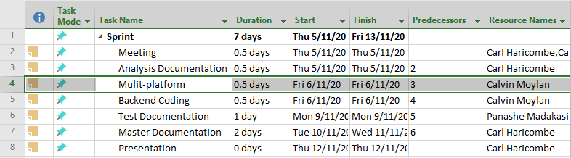

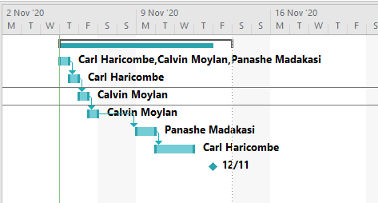

## Notes:

### Meeting

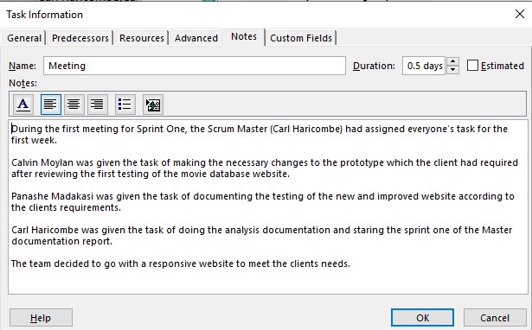

### Analysis Documentation

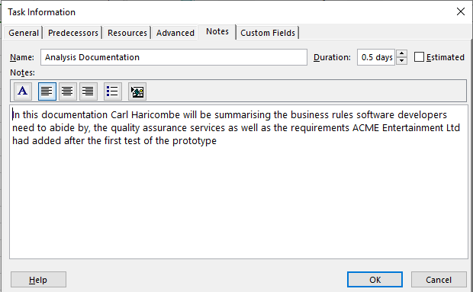

### Multi-platform

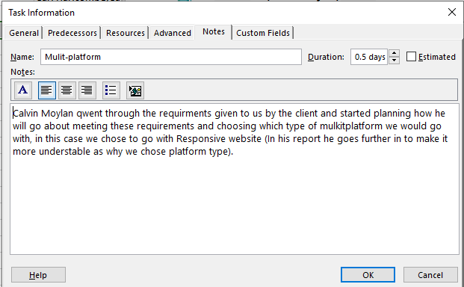

### Backend Code

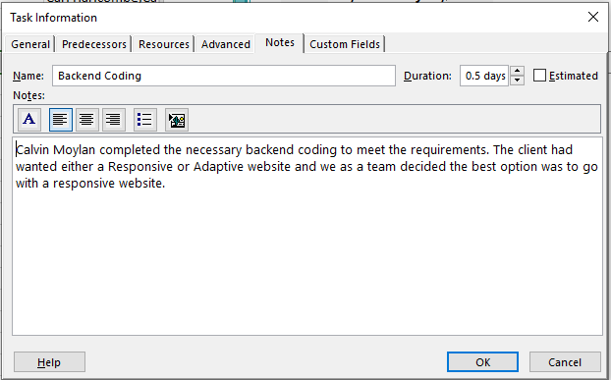

### Test Documentation

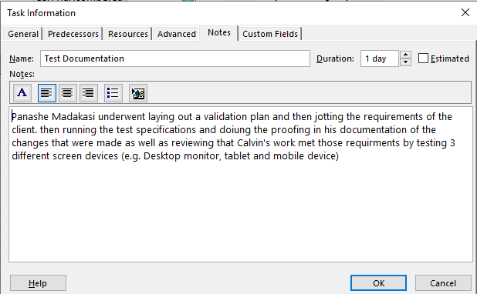

### Master Documentation

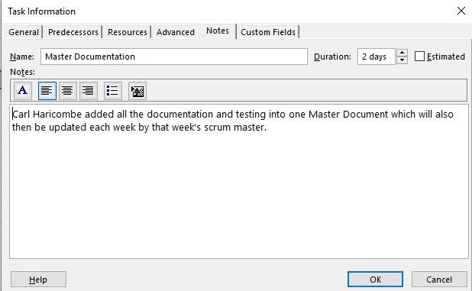

### Presentation

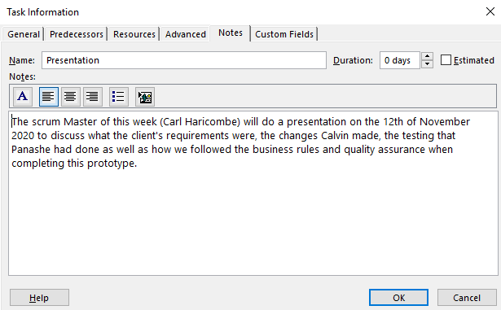

# Source Control System

This refers to the system used to track our changes and progress. Calvin Moylan had created a group project folder and made myself and Panashe Madakasi contributors. This way we were able to keep everyone updated on our progress but also to check that we are doing our part and following through with additional advice or extra data we may feel the other is missing.

## First edition

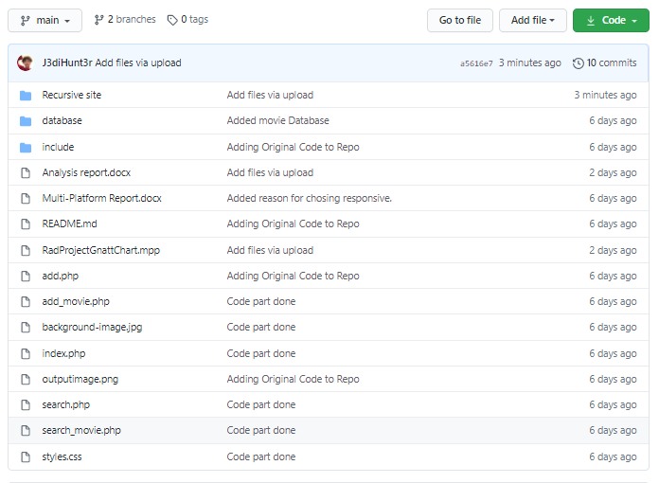

Adjust were made as you can see the above folder was cluttered with the updated php files. I then moved them into a folder called “Responsive Multiplatform site” (this site is the updated version of the original site, containing the new code required by the client). The test document was also not added at that time.

## Final edition

### Main

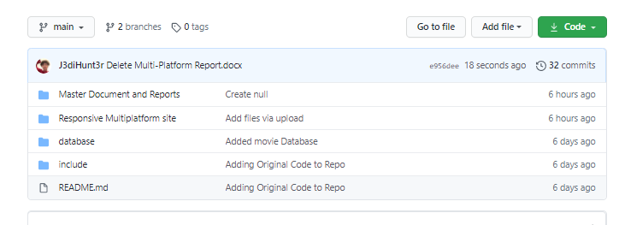

### Responsive Multiplatform site

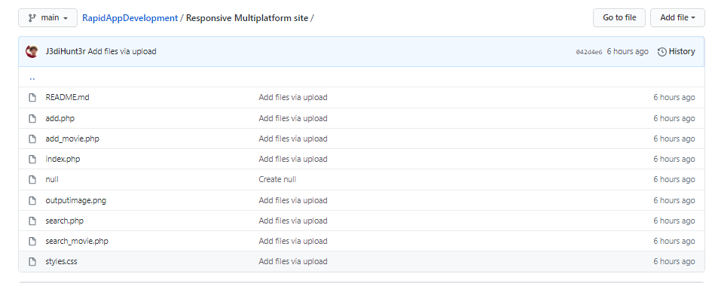

# Multiplatform Report

To make sure the website met the criteria of being capable of supporting multiple platform, I chose to go with the responsive design. This means all website elements stay in the same position and are resized to make sure they fit on all devices. I chose this over adaptive design as the website was almost already in a state where it could easily be converted to responsive design thanks to the simplistic design of the prototype. The website meets this requirement as it is now able to resize the element to fit on screen. This is in contrast to the prototype which didn’t have support for responsive or adaptive design which lead to element clipping out of bounds of the screen when shrunk.

I went about making the website responsive design by setting each main element a max width and setting their width to auto. This made it so they only need to be as big as need and also makes sure that each element was no too big for the screen. The biggest problem was the search table which would constantly clip once shrunk. I fixed this by making the words inside the cells wrap text which allowed the table to be shrunk even further to allow viewing on a smaller device.

This report was completed by Calvin Moylan

# Test Methodology

## RAD (Rapid Application Development)

* Using Rapid application Development allowed our team to quickly create a website that connects to a movie database and as a search function, by using a prototype already created and tailoring it to the client’s needs of having the website being responsive or adaptive significantly reduces the development time and allows for a fast delivery.

# Testing strategy

For testing this we will be using a behavioral testing strategy, this focuses on functions, workflow and performance of the prototype. Behavioral testing can also be classified as black box tested where the testing is done through the perspective of the ender user. The testing covers multiple functions that the user would encounter, using black boxes testing would be the closest to how the user would be using the website and would also assure us that the code is working as intended.

## Quality Assurance

* Quality assurance will up to the Cites management standards evaluation project performance and the hand off complies with customer requirements.

# Testing Environment

|  |  |
| --- | --- |
| **OS** | **Browser** |
| Windows 10 | Chrome |
| Windows 10 | Microsoft edge |
| Windows 10 | Internet explorer |
| Mac OS | Chrome |
| Mac OS | Safari |
| Simulated iPhone (5/se) | Chrome |
| Simulated iPhone (6/7/8)+ | Chrome |
| Simulated iPhone (X) | Chrome |
| Simulated iPad and IPad (Pro) | Chrome |
| Simulated Galaxy Note 2 | Chrome |

The use of google Chrome’s developer tools and mainly the use of the Device tool bar will allow us to simulate having the prototype running on mobile devices without having to run the prototype on the device. The Device tool bar displays the screen size of the selected device and only allows the developer to use the website as if it was being used on that device.

## Hardware requirements

* Windows 10 (Computer)
* iMac or Mac book (Computer
* Internet connection (Wifi or Ethernet connection, modem)
* Peripherals (mouse and keyboard)
* Monitor

# Test Cases

|  |  |
| --- | --- |
| Prototye | Prototype with clients Requirements |
| Google Chrome | Google Chrome |
|  |  |
| Microsft edge | Microsoft egde |
|  |  |
| Microsoft Edge (Resized) | Microsoft Edge (Resized) |
|  |  |
| Internet explorer | Internet explorer |
|  |  |
| Internet explorer (Resized) | Internet explorer (Resized) |
|  |  |
| Simulated iPhone (5/se) | Simulated iPhone (5/se) |
|  |  |
| Simulated iPhone (6/7/8)+ | Simulated iPhone (6/7/8)+ |
|  |  |
| Simulated iPhone (X) | Simulated iPhone (X) |
|  |  |
| Simulated iPad and IPad (Pro) | Simulated iPad and IPad (Pro) |
|  |  |
| Simulated IPad (side view) | Simulated IPad (side view) |
|  |  |
| Simulated Galaxy Note 2 | Simulated Galaxy Note 2 |
|  |  |